Document Title: | Accelerator and Beam Modes
Description: | Technical Concept for definition and integration of Accelerator Modes and Beam Modes in the accelerator control system
Division/Organization: | CSCO, PBSP
Field of application: | Project FAIR@GSI, existing GSI accelerator facility
Version | V 0.2

Abstract
This technical concept proposes two fundamental modes: the 'accelerator mode' covering rule sets and operational sequence outside of beam operation and that are defined per accelerator or beam-line section (e.g. shutdown, setup, physics run, etc.); and the 'beam mode' covering rule sets during beam operation and that are defined per accelerator or beam-line section and Beam-Production-Chain (e.g. no beam, pilot beam, stable beam, etc.).
The purpose of these modes is to communicate the intended accelerator operation, and to condition the various control sub-system responses (e.g. archiving, interlock and fast-beam-abort systems, management of critical settings, etc.). The accelerator control system will distribute this information to the accelerator devices, experiments and wider FAIR community.

Prepared by: | Checked by: | Approved by MPLs + Mks:
R. Steinhagen  R. Bär | S. Jülicher (CO)  I. Lehmann  C. Omet (SIS-100 MP)  D. Ondreka (System Planning)  A. Reiter (BI)  P. Schütt (Operation)  D. Severin | F. Hagenbuck (HEBT)  M. Winkler (Super-FRS)  O. Dolinskyy (CR)  R. Brodhage (p-Linac)  P. Spiller (SIS-100)  K. Knie (p-bar Separator)  H. Reich-Sprenger (Common Systems)  H. Kollmus (Cryogenics)  R. Bär (Controls)  R. Steinhagen(FAIR Comm. & Control)  S. Reimann (Operation)  L. Dahl (General Systems)  R. Hollinger (Ionen Quellen)  H. Vorman (Unilac)  J. Stadlmann (SiS-18)  C. Kleffner (HEST)  M. Steck (ESR)  F. Herfurth (CRYRING/ HITRAP)

Template History:

Version | Prepared by: | Checked, Date | Released, Date | Comment

Document History:

Version | Prepared by: | Checked, Date | Released, Date | Comment
V 0.1 | R. Steinhagen, R. Bär |  |  | Initial version based on preparatory work and discussions in the FAIR Commissioning and Control Working Group
V 0.2 |  |  | 2014-10-16 | Some modifications and comments based on feedback from early 'Checked by' distribution

Table of Contents
Table of Contents
Purpose and Classification of the document 4
1.Accelerator Modes 6
1.1.Definition of Accelerator Modes 6
1.2.Accelerator Status Transitions 8
2.Mode Constraints 8
3.Beam Modes 9
3.1.Definition of Beam Modes 9
3.2.Mode Transitions and Constraints 10
3.3.Open Issues 11
4.Actual States 12
4.1.Beam-Presence Flag (BPF) 12
4.2.Setup-Beam Flag (SBF) 12
4.3.Injection Permit 13
4.4.Extraction Permit 13
4.5.Movable-Device-Permit 13
5.Usage and Management of Modes 14
5.1.Users of the Modes 14
5.2.Management of Modes 14
5.3.Distribution of the Modes 14
Related Documents 15

Purpose and Classification of the document
The purpose of this document is to introduce and formalise the definition of “modes” and “actual states” for the accelerator control system implementation of FAIR. The range covers all new FAIR accelerator machines as well as part of the existing GSI injector chain with the intention to implement the concept for the full GSI/FAIR complex after complete refurbishment of the control system.
The main purpose of formal accelerator and beam modes are
- to communicate the intended accelerator operation to the experiments and wider FAIR community, and
- to condition the various control sub-system responses (e.g. archiving, interlock and fast beam-abort systems, management of critical settings, etc.).

Concept of Modes and Actual State Flags
'Modes' are deliberate user-driven states (references or 'desired target') that follow and track the normal operational sequences (e.g. 'no beam' → 'pilot beam' → 'intensity ramp-up' → 'adjust' → 'stable beams for physics'), and that provide the possibility to define associated rules depending on the specific phase of operation. The mode changes will be initially tracked by operators and subsequently by semi-automated sequencer.
Some of the application using 'modes' include, for example, limiting parameter changes while the experiments are taking data (aka. 'Stable Beams' or production runs), limiting of high-intensity beam being requested or injected into a previously untested machine without having its settings being checked with low-intensity pilot beam, or to block certain operation during unsafe mode of operation (e.g. moving beam screens during production runs or while high-intensity beam is being extracted; settings changes that could impact the efficiency or safety of machine operation).
The 'actual states' differ with respect to the 'modes' insofar that they describe the actual measured state of the accelerator or beam. The 'states' perviate the accelerator and beam mode definitions, and could be equally used for ad-hoc or post condition of the control system (e.g. beam-based interlocks). Some of the actual states that are proposed and that shall be integrated and transmitted alongside with the modes are the Beam-Presence-Flag (BPF), the Setup-Beam-Flag (SBF), and the Injection- and Extraction-Permit that are defined in more detail below. While the transmission of the modes is not time-critical, there are certain real-time requirements on the transmission of BPF, SBF and Injection/Extraction Permit since they are foreseen to be used also by the interlock and machine protection system.
The definition of 'modes' shall not be mixed with 'actual states' to prevent circular dependencies, priority or causality inversions. For example: while the 'No Beam' mode declares the intend (as an agreement) that there will be no beam in the machine, only the 'Beam Presence Flag' measures the actual state whether there is (or was) beam in the machine. A consequence and trivial example rule using this definition would be to issue an interlock if the if the 'BPF=true' while the beam mode 'No Beam' is set.
Based on discussions (…) the following two groups of modes are suggested:
- “Accelerator Modes”, that cover rule sets and operational sequence outside of beam operation and that are defined per accelerator or transfer-line segment,
- “Beam Modes”, that cover rule sets during beam operation and that are defined per accelerator or transfer-line segment and Beam-Production-Chain (BPC).

Table 1 summarises the possible accelerator- and beam-mode combinations.
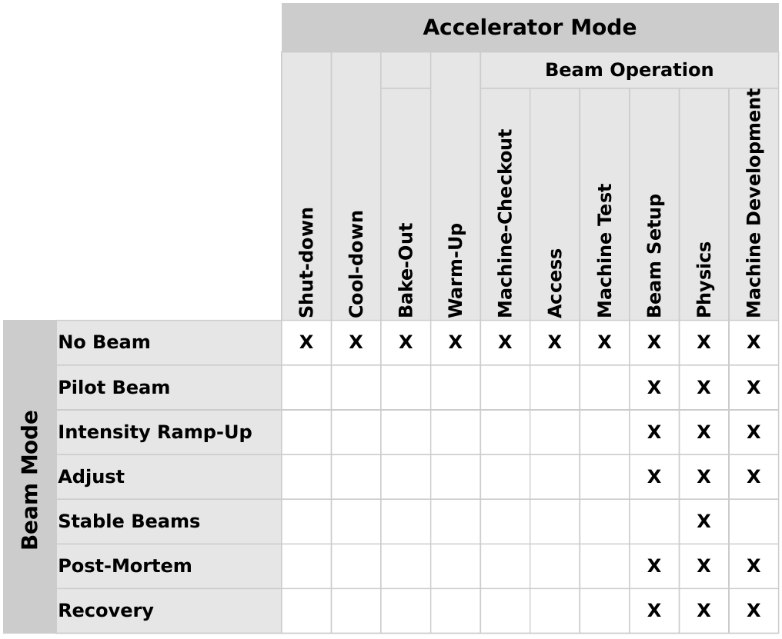Table 1: Accelerator vs. Beam Mode Matrix

Accelerator Modes
The modes to be used as 'Accelerator Modes' follow the existing annual life-cycle of the accelerator facility and are formalised as:

Modes without beam
- SHUT-DOWN
- COOLDOWN
- BAKE-OUT
- WARM-UP
- MACHINE-CHECKOUT
- MACHINE-TEST
- ACCESS
Modes with beam
- BEAM-SETUP (or MACHINE-SETUP).
- PHYSICS-RUN
- MACHINE-DEVELOPMENT
Accelerator Modes are independent for every machine or transfer-line segment. The transfer-line segments as specified in the HEBT layout may be grouped into larger functional blocks if practical.
The valid set of Accelerator Modes depend on the nature of the respective machine or beam-line section (e.g. COOLDOWN or WARM-UP only for cryogenic machines).
It shall be noted that, besides formalising their names, these modes are not a new concept but already being practised during normal operation at GSI and accounted for in the annual beam schedules (aka. “Strahlzeitplan”) and electronic log-books. What is new is that the new control system for FAIR will be made aware of these modes which in turn opens the possibility to derive automated rules, automated statistics and other features from these modes.

Definition of Accelerator Modes
The Accelerator Modes are defined as follows:

- SHUT-DOWN
Used when the machine is in a mode of long-term maintenance or repairs, and could imply (as an example rule) the possibility of open or controlled access, and the machine being not powered.
Further discussions are needed whether this mode needs to distinguish a 'warm' and 'cold' shut-down (e.g. SIS100 being kept at 4 K).

- COOL-DOWN
Required for superconducting machines (in particular for SIS100 and Super-FRS) during the period when the machines are being cooled down from ambient temperature by the cryo-system (lasting typically 2-3 weeks), and could, for example, imply limited or no access (if safety necessitates it).

- BAKE-OUT
Similar to COOLDOWN for the other normal conducting accelerators and transfer-lines but covering the vacuum bake-out period (also about 2 weeks).

- WARM-UP
Required in particular superconducting machines (e.g. SIS100, Super-FRS) during the period when the machines are being warmed up, and could, for example, imply limited or no access (if safety necessitates it).

- RECOVERY
Used after, for example, a major quench or partial vacuum loss outside of normal beam operation and lasting typically few hours to days. This mode would include pre-cycling of magnets to stabilise their hysteresis and revalidation of the proper function of power converter, quench protection systems, etc.

- MACHINE-CHECKOUT
Covers operational tests and dry-runs without beam in view of beam operation (e.g. power converter calibration, magnet patrol, etc.). This mode is typically used only once per year, only after a long shut-down, and typically a few weeks before regular re-commissioning and operation with beam starts. This would also mark the end of regular shut-down operation and start of operation with beam.

- MACHINE-TEST
Is a priori is similar but for accounting purposes distinguished from MACHINE-CHECKOUT. The mode is intended to be used to cover similar activities during beam operation or shut-down. The expectation is that the machine is closed and all system in a ready-for-beam state to permit short-lasting dry-runs to test new control schemes, new front-ends, RF conditioning, tests that can be done without beam (e.g. when ion sources are being exchanged or the linac is unavailable) and for OP training purposes. This mode is needed from an operational point of view but is used if the time allocated should neither be accounted as 'Physics' nor 'Machine-Development' during the annual statistics.

- ACCESS
Intended to be used whenever a controlled machine access is given during beam operation for specific interventions (repair, change of experimental setup). The main purpose of this mode is to keep track of beam (un-)availability during beam operation (annual accounting) and to stop the concerned part of the machine in a controlled way (ie. controlled soft-powering-down of magnets, rather than using interlocks that abruptly stop the power supplies and leave them in a fault state after an access).

The following set of accelerator modes describe operation with beam but are proposed to be further divided to distinguish between the main aim or user of accelerator operation and to provide a more fine-grained accounting of beam times spent.

- BEAM-SETUP (or MACHINE-SETUP)
Used during the initial and subsequent re-commissioning after long shut-down and could include OP training with beam.

- PHYSICS-RUN
State when the primary intended purpose of the machine is to deliver beam for atomic, anti-matter, nuclear and bio-medical applications. Decisions that would affect the beam availability (e.g. inserting of screens for parallel users) would be driven by the primary experiments with this mode.

- MACHINE-DEVELOPMENT
Used when the primary intended purpose of the machine is to perform beam physics or accelerator physics studies. During this mode the prerogative of, for example, inserting screens into transfer-lines would be at the discretion of the accelerator physics groups.

Accelerator Status Transitions
The 'Accelerator Mode' for a respective machine or beam-line segment will be explicitly set or changed by an authorized operator.

Mode Constraints
[…]

Respect modes in accelerator chain: e.g. cannot have down-stream machine in 'production beams' while up-stream machine is e.g. in 'ACCESS', 'PILOT BEAMS', etc.

Beam Modes
The 'Beam Modes' follow the life-cycle (e.g. 'no beam' → 'pilot beam' → 'intensity ramp-up' → 'adjust' → 'stable beams for physics') of the so called 'Beam-Production-Chain' (BPC). The BPC is an organisational control system structure to manage parallel operation and beam transfer through the FAIR accelerator facility. It describes a ‘beam’ through the facility including the sequence and parameters of beam lines and accelerators, starting from the ion-source up to an experimental cave (e.g. APPA, CBM, Super-FRS, …).
The BPC structure includes the definition of target beam parameters (set values) like, for example, isotope type, energy per nucleon, charge per nucleon, peak intensity, etc. Several BPC are grouped to a pre-defined 'Beam Pattern' that is typically executed periodically. While being pre-defined, these patterns can, however, be changed within minutes.
The 'Beam Modes' are specific for a given BPC but also transfer-line segment (or group of the latter). This implies that e.g. different accelerator can have different beam modes (e.g. the beam mode for the BPC delivering beam to CBM being 'Pilot Beam' in SIS18 and 'No Beam' in SIS100).
The first beam modes follow the natural sequence of how new beams are typically being set-up in an accelerator. In that respect (similar to the Accelerator Modes) these are not new but formalise the existing operation concept, integrate and would make the control system aware of them.
The modes to be used as 'Beam Modes' are defined per accelerator / transfer-line segment and beam production chain.
Beam modes are different for beam production chains, e.g. SIS100 could be in 'PRODUCTION' for U28+ but in SETUP for Au79+ beam production chains
They are formalized as follows:

- NO BEAM
- PILOT BEAM
- INTENSITY RAMP-UP
- ADJUST
- STABLE BEAMS
- POST-MORTEM or BEAM-DUMP
- RECOVERY

Definition of Beam Modes
The Beam Modes are defined as follows:

- NO BEAM
Used by the control system to suppress by design beam requests or injections into a given ring or transfer-line.

- PILOT BEAM
Used while establishing the main machine functions and parameters such as injection steering, RF capture, ramp, orbit, tune and chromaticity, simple optics checks, proper slow or fast extraction. This mode implies that these operations are done typically with low setup-beam intensities, and that optics parameters can be changed without limits on their value or range.

- INTENSITY RAMP-UP
Used while ramping-up beam intensities and after the basic accelerator functions have been established. This mode is used to perform minor adjustments related to increasing the beam intensities and to validate related machine protection functionalities. It would be also linked to more strict limits on optics and parameter changes. This mode is necessary for a safe and reliable operation with high-intensities but could be skipped if operation with low beam intensities is targeted.

- ADJUST
While the main focus of the 'Pilot Beam' and 'Intensity Ramp-up' mode focus on the beam setup from an accelerator point of view, this mode focuses and is used to perform minor parameter changes or re-tuning in view of achieving the physics experiment's parameters.

- STABLE BEAMS
Used to indicate that the main intend is to deliver stable beam to the given experiment. Very limited machine tuning and (if at all) parameter changes would be allowed during this mode in order to avoid transients or spikes that would hamper the experiment's data taking. Leaving this mode may require a hand-shake or release by the experiments to provide them the possibility to return their detectors into a safe state.

- POST-MORTEM
Used in response to a quench, machine-protection action, partial vacuum loss (e.g. dynamic vacuum loss) or another major beam loss that needs to be analysed before normal beam operation can be continued.

- RECOVERY
Used to indicate the time period required for recovering from a severe post-mortem (e.g. quench of a single or string of magnets) and covers the period to validate powering, cycling of the magnets, and other essential systems.

Mode Transitions and Constraints

The proposed state diagram is illustrated in Figure 1:

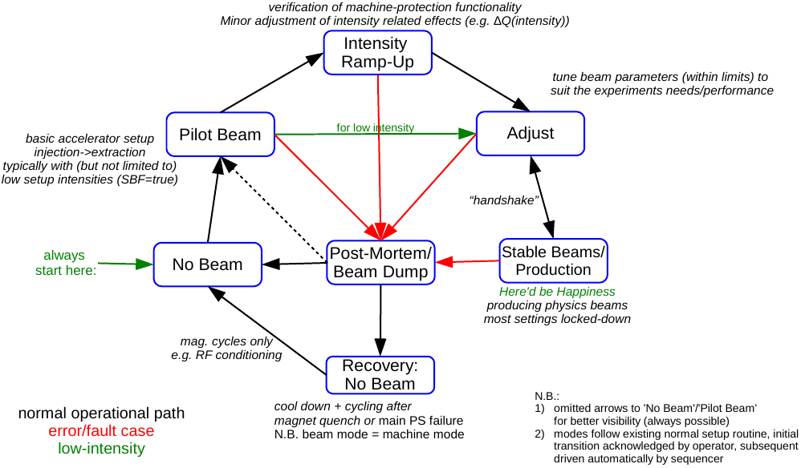Illustration 1: FAIR Beam Modes – State Diagram

The mode changes will be initially tracked by operators and subsequently by semi-automated sequencer.

Open Issues
- Further accelerator modes such as 'INJECTION','ACCUMULATION', 'RAMP' and 'FLAT-TOP' may be considered in particular for slow-cycling storage rings (ie. ESR and HESR). Their necessity needs to be clarified.
- Need to check for accelerator modes that are global (e.g. access, recover, cool-down, etc.)

Actual States

The following flags and permits are proposed.

Beam-Presence Flag (BPF)
The 'Beam-Presence-Flag' shall indicate that a given BPC and associated settings have been validated and are compatible with pilot- or physics-beam. The main purpose of this flag is to prevent high-intensity injections into a machine with new or untested magnetic settings or modified machine conditions that might be potentially incompatible with machine-protection or activation minimisation of the machine.
The flag would needs to be defined per accelerator or transfer-line segment (where necessary). The flag is being set whenever the basic accelerator function has been confirmed with beam (e.g. acceptable performance of: injection, RF capture, acceleration/ramp, transmission, orbit, Q/Q', loss patterns, …).
The initial checks and references would be taken by an operator or experienced machine expert. Subsequent cycles would be re-validated and checked against these references. The BPF shall expire if untested for a prolonged period or if settings have substantially changed, and could force, for example, re-checking the cycle settings with pilot beam before continuing with high-intensity beams.

Setup-Beam Flag (SBF)
The 'Setup-Beam-Flag' shall indicate beams (with typically low-intensities) used specifically during the initial setup of the BPC. The definition derives from the experience and existing usage at LHC: too strict interlocks and rules that are required to ensure a safe and reliable high-intensity operation may at the same unnecessarily impact machine availability during beam setup with low-intensities.
The SBF facilitates the flexibility of masking some of these interlocks during low-intensity operation, while ensuring that these interlocks are taken automatically into account when operating with unsafe high-intensity beam.
The SBF is defined per accelerator and beam-line segment. It needs to be evaluated whether the SBF needs to be further multiplexed for each given BPCs (N.B. FAIR may possibly need different SBF thresholds depending on the particle species and experiment that needs to be protected).
The flag needs to be derived automatically from the beam current transformer (simple threshold). Most of the SBF-maskable interlock candidates are related to more complex or beam-instrumentation-derived interlocks such as beam transmission, beam loss monitoring, beam screens and multi-wire grids.
Some use-case and proposed rule examples to illustrate the SBF:
a) While 20% beam transmissions may be temporarily acceptable during setup or low-intensity operation (ie. transmission interlock being masked), the associated interlock should not be kept permanently disabled or forgotten once moving to high-intensity operation.
b) In order to self-protect sensitive beam screens, wire-grids and other similar devices, these devices would by-default create an extraction (or injection) interlock (↔fail-safe logic) whenever they are inserted into the beam line or ring. However, these interlock could be masked if the 'SBF==true' and possible other additional beam mode requirements are fulfilled (e.g. not in 'STABLE BEAMS' or 'INTENSITY RAMP-UP', etc.).

Injection Permit
The 'Injection Permit' is defined per accelerator and shall be used inhibit particle beam injections in case the given accelerator is not ready or being set-up to receive beam from the pre-injectors. The signal is derived from combined state of the accelerator hardware (e.g. power converter, vacuum system, front-ends, critical beam instrumentation, …) and software systems that are required for injection, acceleration and extraction of the given beam. The injection suppression is performed via the timing and/or injection kicker systems.
It is planned to provide the required surveillance through a combination of programmable hardware- and software-based interlock systems [reference to the FAIR Software Interlock & Fast-Beam-Abort-System].

Extraction Permit
The 'Extraction Permit' is a complementary signal to the 'Injection Permit' and shall be used to suppress particle beam extractions in case the subsequent beam-line, accelerator or experiment is not ready to receive beam (e.g. hardware fault, system being reconfigured, ...). In case the permit is absent, the beam shall either be dumped inside the accelerator (e.g. programmed dump) at the end of the cycle, or – if time permits – suppressed in the pre-accelerator before it is being injected.
Similar to the 'Injection Permit', the combinatory logic which beam-line segments, accelerators and experiments are taken into account need to be kept programmable.

Movable-Device-Permit
The 'Movable-Device-Permit' shall indicate whether movable devices (e.g. such as vacuum valves, wire grids, beam screen, etc.) are allowed to be moved into the beam. This flag is derived from the logical combination of all 'beam modes' for a given accelerator or transfer-line segment: the flag shall be 'TRUE' if all beam modes for a given ring or transfer-line are in 'NO-BEAM', 'PILOT', 'POST-MORTEM' or 'RECOVERY', and 'FALSE' otherwise.
Some use-case and proposed rule examples to illustrate the MDP:
If a device needs to be inserted while the BPC's 'beam mode' of an experiment is in 'STABLE BEAMS', the experiment would first need to drop back to 'PILOT' or 'NO-BEAM' before the device is allowed to move in. The required mode change is at the discretion of the primary experiment (for the 'PHYSICS' accelerator mode) or operator (for the 'MACHINE DEVELOPMENT' accelerator mode).
On the other hand, it must not be possible to switch the BPC back to 'STABLE BEAMS' while any movable device is in the beam path.

Usage and Management of Modes

Users of the Modes
Being fundamental for accelerator operation and control, the modes are used to communicate the users the overall state of machine operations. The modes are distributed for information, and for conditioning sub-system response.
The users of Accelerator and Beam Modes will include:
- Role Based Access (RBAC) for system security and software application control rights, etc.
- Accelerator control software for conditioning sub-system response (such as data acquisition) and publishing
- Operational log book (oLog)
- Software Interlock System
- …

Management of Modes
All accelerator and beam modes of the full facility will be stored and managed in the LSA database in an appropriate table.
It is envisaged that a finite state machine will be responsible for maintaining the modes and for ensuring legal transitions between states and for initiating the distribution of any mode changes to the systems concerned.
All mode-changes are time-stamped and further logged in the diagnostic logging database (DIALOG).

Distribution of the Modes
The modes will be made available by a number of channels. These will include
- high level publishing mechanism from LSA for clients
- via the timing system (tbd)
- ...

Related Documents
- FAIR Common Specification F-CS-C-01e, “Accelerator Control System”
- FAIR specification document F-TC-C-06e, “Multiplexing and Data Indexing Concept”

